TOXIC COMMENT FILTERING
For live gaming chat
Pipeline: Data cleaning -> TF-IDF features -> One-vs-Rest Logistic regression
-> Severity scoring (0–5) → Moderation action mapping

1. Project Objective
Live gaming chat moves fast, is written in slang-heavy shorthand, and mixes several kinds of bad behaviour in a single message. This project builds a machine-learning system that reads a chat message and:
- Classify — classifies it into one or more of five categories — spam, insult, profanity, hate_speech, or non_toxic (multi-label, since a message can belong to more than one category at once);
- Score — scores its severity on a 0–5 scale based on how confident the model is in the worst category it flagged;
- Act — recommends a moderation action, escalating from no action through a soft flag, a warning, a temporary mute, up to an auto-ban with mandatory human review.
The result is an end-to-end moderation pipeline that could sit behind a live chat feed and make a real-time recommendation for every message a player sends.

2. Dataset
2.1 Why a Synthetic Dataset
- The original brief pointed to the Kaggle Jigsaw Toxic Comment Classification dataset. Two practical issues ruled it out for this build: the sandbox environment has no network access to Kaggle, and Jigsaw's real label set (toxic, severe_toxic, obscene, threat, insult, identity_hate) does not include a spam category — which matters a great deal for gaming chat, where link-spam and self-promotion are common. The notebook therefore trains on a synthetic, template-based gaming-chat dataset that mirrors the project's five target categories, so the complete pipeline — cleaning, modelling, scoring, and moderation logic — can be built and demonstrated end to end. The same code can be pointed at the real Jigsaw data later with minimal changes.

2.2 Structure
- The dataset contains 677 messages across 7 columns: an id, the raw message text, and five binary indicator columns — one per label. Because a message can trigger more than one column at a time (e.g. an insult that is also profane), this is a multi-label problem rather than a single-label one.
Property | Value
Rows (messages) | 677
Columns | id, message, spam, insult, profanity, hate_speech, non_toxic
Label type | Multi-label (binary indicator per category)
Categories | spam · insult · profanity · hate_speech · non_toxic

2.3 Class Distribution
- Counting how many messages fall into each category (labels can overlap) shows the natural balance of the dataset before any modelling happens:
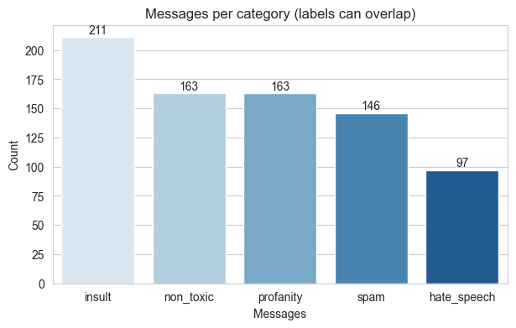

3. Preprocessing
Gaming chat is short, informal, and full of shorthand (u, gg, wtf, brb), emoji, and links, so raw messages are cleaned before they reach the model. A dedicated preprocessing module applies six steps in order:
- Lowercase — Convert all text to lowercase.
- Remove URLs — Strip out URLs.
- Remove emojis — Strip out emoji characters.
- Expand contractions — Expand standard English contractions, e.g. don't -> do not.
- Expand slang — Expand gaming/chat shorthand using a custom slang dictionary, e.g. wtf -> what the heck.
- Clean punctuation — Strip punctuation and collapse repeated whitespace.

4. Feature Engineering — TF-IDF
Cleaned messages are converted into numerical features using word-level TF-IDF with both unigrams and bigrams. Bigrams matter here because short toxic phrases (“go back”, “so bad”) carry meaning that individual words alone would miss. The data is then split into training and test sets (80/20), stratified on the non_toxic column so the split preserves the overall toxic/clean balance.
Split | Shape (messages × TF-IDF features)
Training set | 541 × 769
Test set | 136 × 769

5. Model — Multi-Label Classification
The classifier is a Logistic Regression model wrapped in a MultiOutputClassifier, which trains one independent binary classifier per label (a One-vs-Rest style approach). This keeps the model simple, fast to train, and easy to interpret — a good fit for a small-to-medium chat-moderation dataset, and consistent with the brief's request for a traditional ML approach rather than deep learning.
- Key setting — class_weight = “balanced”, which automatically re-weights each label's classes to counter imbalance between toxic and non-toxic messages;
- Key setting — max_iter = 1000, giving the optimizer enough iterations to converge reliably on the TF-IDF feature space.

6. Model Evaluation
Since the dataset has no severe_toxic column (the closest real-world equivalent to Jigsaw's most serious label), hate_speech is treated as the severity benchmark and checked against an 80% precision bar — the idea being that the model should very rarely cry “hate speech” by mistake.
Category | Precision | Recall | F1-score | Support
spam | 1.00 | 1.00 | 1.00 | 28
insult | 0.84 | 1.00 | 0.91 | 41
profanity | 0.80 | 0.85 | 0.82 | 33
hate_speech | 1.00 | 1.00 | 1.00 | 16
non_toxic | 1.00 | 1.00 | 1.00 | 33
micro avg | 0.91 | 0.97 | 0.94 | 151
macro avg | 0.93 | 0.97 | 0.95 | 151
weighted avg | 0.91 | 0.97 | 0.94 | 151
samples avg | 0.94 | 0.98 | 0.95 | 151
hate_speech precision (severe-toxic equivalent): 1.000 → requirement ≥ 0.80: PASS
Every category clears strong precision and recall, with profanity as the weakest label (0.80 precision / 0.85 recall) — sensible, since profanity phrasing overlaps the most with ordinary heated gaming banter (“damn it”, “holy crap”).

6.2 Confusion Matrices per Label
Each label gets its own 2×2 confusion matrix on the held-out test set, showing true vs. predicted positives and negatives side by side:
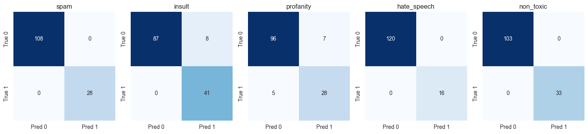

7. Severity Scoring (0–5)
Each category carries a severity weight reflecting how serious it is when the model is maximally confident:
Category | Weight
non_toxic | 0
spam | 2
profanity | 3
insult | 4
hate_speech | 5
Severity = weight × probability of the flagged category with the highest such value, rounded to the nearest whole number and capped to the 0–5 range.
Only categories the model actually flags — probability ≥ 0.5 — are considered. This design rewards both how bad a category is and how confident the model is in it, so a hesitant hate_speech call and a confident one land at different severities rather than being treated identically.

8. Moderation Action Thresholds
Severity scores map onto a fixed escalation ladder of moderation actions:
Min Severity | Max Severity | Action
0 | 0 | No action – message is clean
1 | 2 | Soft flag / log only – monitor user
3 | 3 | Warning issued to user
4 | 4 | Mute user (temporary, e.g. 10 min) + remove message
5 | 5 | Auto-ban / escalate to human moderator immediately

9. Simulated Live Chat Feed
To mimic a real-time moderation bot, 20 fresh messages are streamed through the full pipeline one at a time — clean, vectorize, predict labels, score severity, map to an action. A sample of the detection log:
User | Message | Predicted Label(s) | Sev. | Action
Player_101 | gg wp everyone that was a great match! | non_toxic | 0 | No action
Player_204 | u are so bad at this game, uninstall pls | insult, profanity | 4 | Mute + remove
Player_309 | FREE VBUCKS!! click the link in my bio now | spam | 2 | Soft flag
Player_117 | wtf bro that lag was so annoying today | profanity | 3 | Warning
Player_450 | can someone help me find the objective on this map | non_toxic | 0 | No action
Player_233 | you're trash, just quit already noob | insult | 4 | Mute + remove
Player_567 | people like you don't belong on this server, go back | insult, hate_speech | 5 | Auto-ban
Player_089 | thx for the heal, that clutch save | non_toxic | 0 | No action
Player_312 | add me on discord for free skins!!! | spam | 2 | Soft flag
Player_178 | holy crap that was such a close round | profanity | 3 | Warning
Player_402 | girls shouldn't even be allowed to play this game | insult, hate_speech | 5 | Auto-ban
Player_265 | gl hf in the next round everyone | non_toxic | 0 | No action
Player_501 | you're pathetic, that was such an awful play | insult, profanity | 3 | Warning
Player_390 | check my stream, follow follow follow for a giveaway | spam | 2 | Soft flag
Player_144 | this patch is straight up garbage ngl | profanity | 3 | Warning
Player_222 | we don't want your kind on our team, leave | insult, hate_speech | 5 | Auto-ban
Player_078 | nice combo, teach me that build sometime | non_toxic | 0 | No action
Player_610 | damn it, i missed that easy shot again | profanity | 2 | Soft flag
Player_333 | DM me to buy a boosted account fast, cheap | spam | 2 | Soft flag
Player_499 | who wants to duo queue for the next few games | non_toxic | 0 | No action

Visualizing the same run shows how often each category fired and how the severity scores were distributed across the batch:
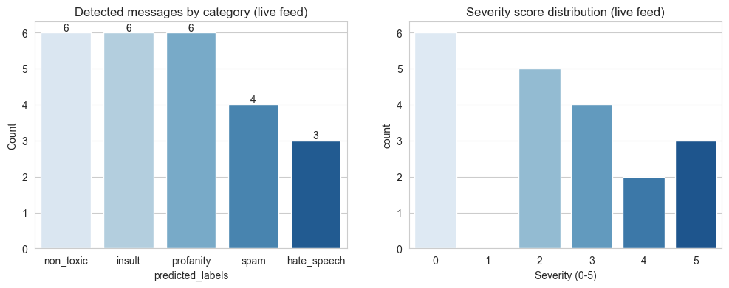
- Of the 20 simulated messages, 3 escalated all the way to severity 5 (auto-ban), each combining insult with hate_speech — consistent with the design goal that the most severe action should require a strong, multi-label signal rather than a single borderline category.

10. Mitigation Strategy Summary
Severity | Trigger Examples | Action | Rationale
0 | Clean chat | No action | Normal conversation, no moderation cost
1–2 | Spam links, mild profanity | Soft flag / log only | Low harm; track repeat patterns without disrupting play
3 | Insults, repeated profanity | Warning issued to user | Give the player a chance to self-correct
4 | Sustained insults / harassment | Temporary mute + message removed | Protect other players immediately, but stay reversible
5 | Hate speech / severe harassment | Auto-ban + escalate to human moderator | Zero-tolerance category; human review confirms before permanent action

11. Design Principles
- Escalating response — Action severity scales with predicted severity rather than applying a single fixed penalty to every flagged message.
- Human-in-the-loop for the worst cases — Severity-5 auto-bans are paired with a mandatory human review queue rather than being fully automatic and irreversible, to control false-positive risk.
- Repeat-offense tracking (future work) — A production system would also weight a user's recent history rather than judging each message in isolation.

12. Conclusion
The pipeline demonstrates that a lightweight, interpretable traditional-ML approach — TF-IDF features feeding One-vs-Rest Logistic Regression — can classify multi-label toxicity in gaming chat with strong precision and recall, comfortably clearing the 80% hate_speech precision bar. Wrapping the classifier output in a severity score and a fixed moderation ladder turns raw predictions into a concrete, explainable moderation decision for every message, and the live-feed simulation shows the full pipeline behaving sensibly end to end. The clearest next step is swapping in a larger, real-world labelled dataset (e.g. Jigsaw, extended with a spam label) and adding repeat-offense history so the same scoring logic can weigh a user's pattern of behaviour, not just a single message.

:

